Divides data into k sets minimizing the standard deviation within each set

Randomly choose two centroids

Calculate distance from every point to either centroid, Classify into two sets by closest

Use centroids of two new sets and repeat first two steps

Iterate until both points converge within a desired amount of error or iterations

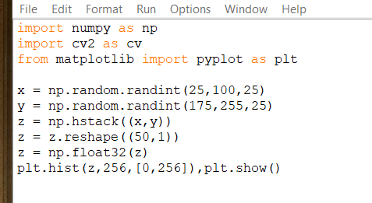

Start out with random one dimensional histogram

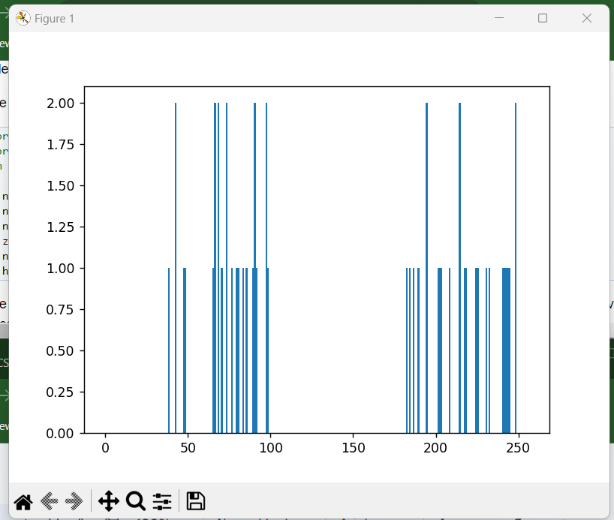

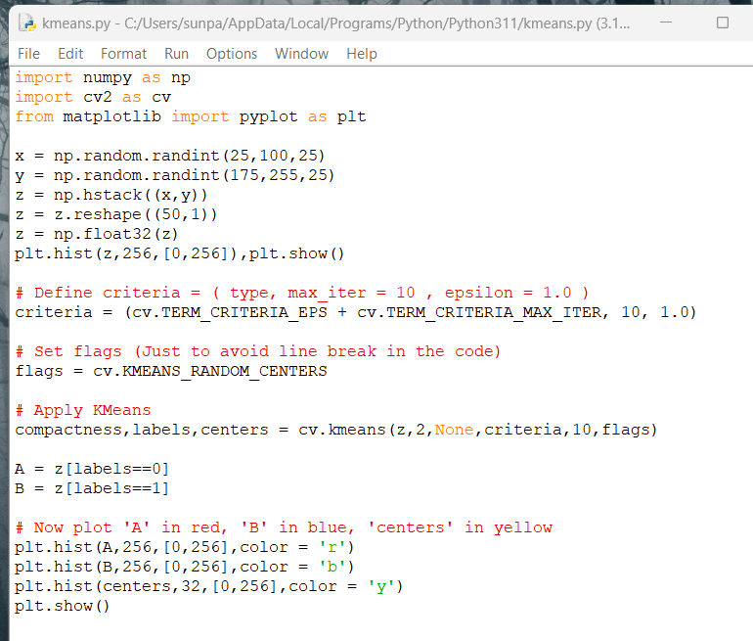

Define criteria for run then apply k means

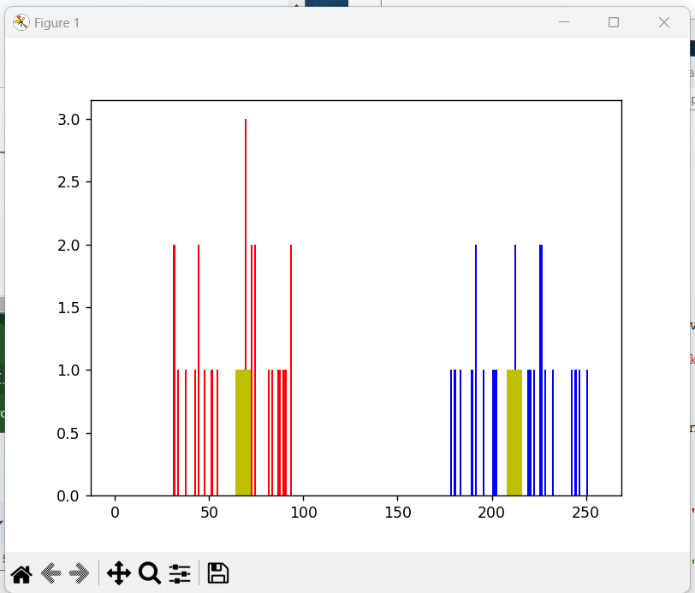

Use 2 features height and weight

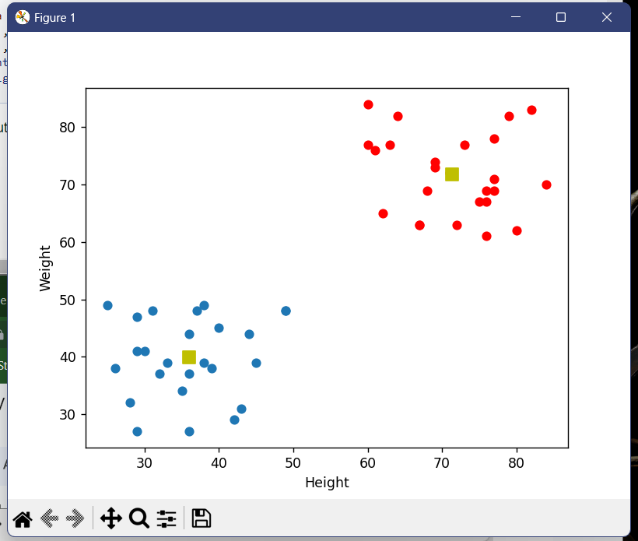

K means clustering for color quantization, divide colors into sets and use average each set in storage

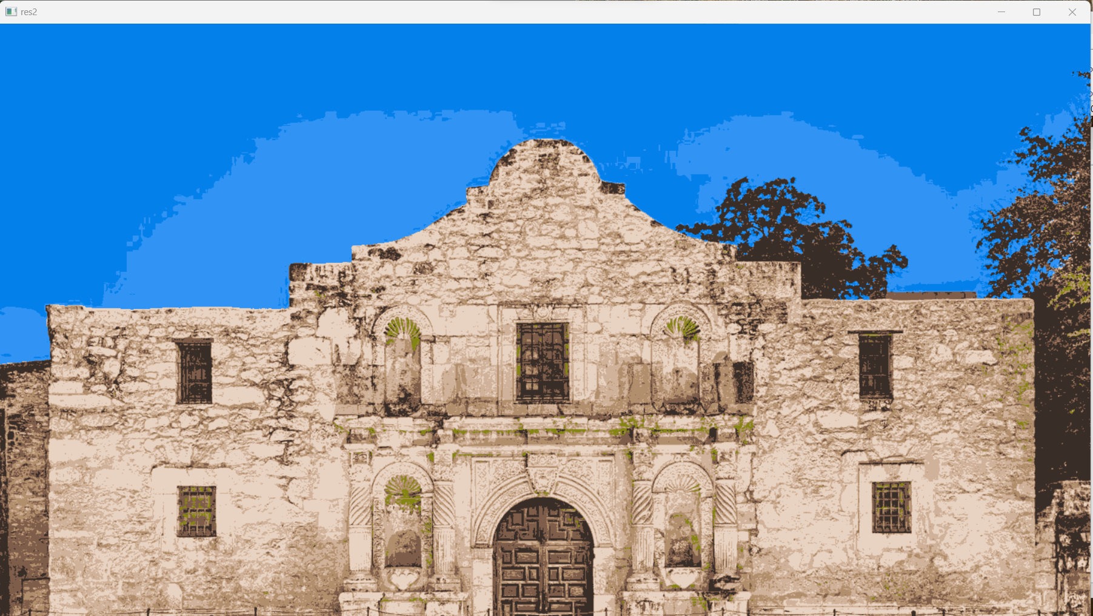

Alamo1.jpg quantized with k = 8 colors

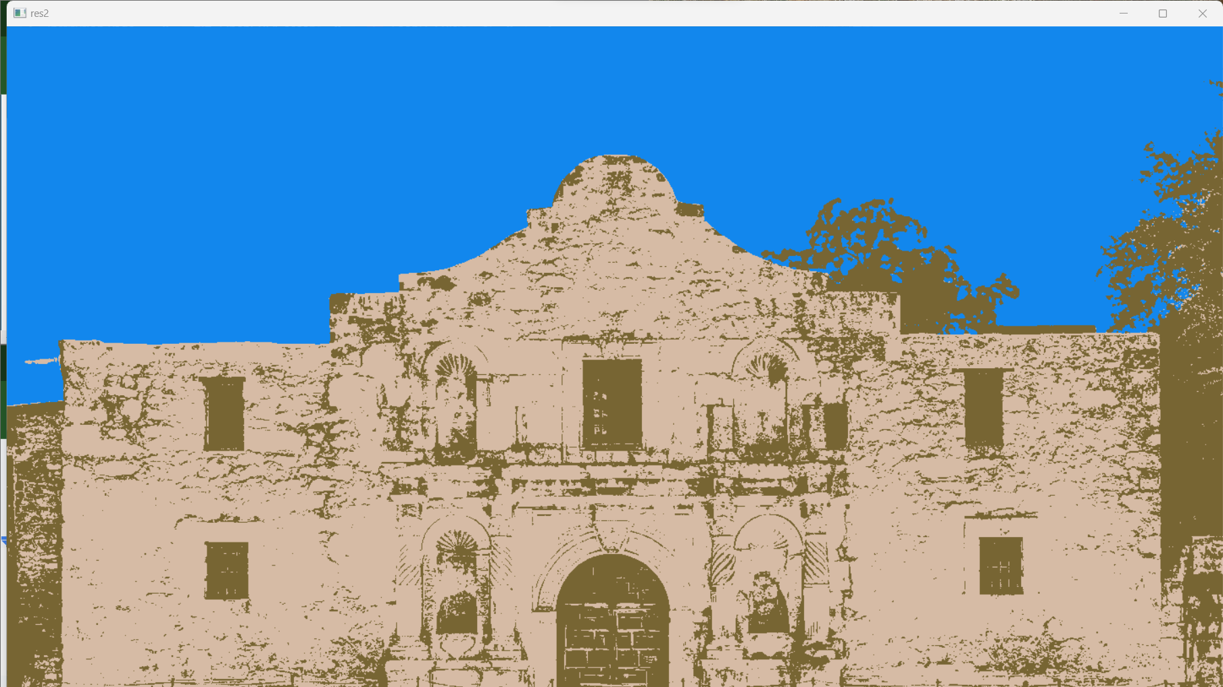

Using k = 3 colors